ITEC 2560 Artificial Intelligence Lab
For this lab you will investigate the abilities of artificial intelligence (AI) tools to generate web pages and code.
You will work in a team of 4 and investigate one AI tool each. If your team has fewer people, then pick one AI tool each and skip the other tool(s).
Upload this document to https://word.cloud.microsoft/ or Google Docs and collaborate on it. Fill in the highlighted sections.
You will work with these AI tools. Each person on your team will work with one of these tools. If you have fewer than 4 people, then skip one of the AI tools.
- ChatGPT https://chatgpt.com/
- Copilot https://copilot.microsoft.com/
- Gemini https://gemini.google.com/
- Claude https://claude.ai/
If you have a preferred AI tool, for example, MetaAI, Grok, DeepSeek etc... you can substitute that tool.

Part 1 Team member first and last names, AI tool chosen
Fill in this table.
Name | AI tool
Zoe Onan Gonzalez Rivera | ChatGPT

Part 2 Generating an about page
You are working as a web developer.
Team 1: Your client is a Minneapolis yoga studio.
Team 2: Your client is a Minneapolis barber shop.
You have been asked to create an “About” page for the business’ website.
Ask your AI tool to generate an about page for your business.
Review the page generated. Your AI tool will probably generate HTML and CSS.
- What assumptions does the AI tool make about the business?
- Does the page meet accessibility best practices?
- What needs to be changed before this page could be used in a real business?
- Is it clear what needs to be changed before the page could be used in a real business?
- Would this page fit into an existing website or would changes be needed?
- What would you need to do differently to use an AI tool to generate a useable page for a real business?
Insert screenshots of each AI tool’s page.

ChatGPT Screenshot
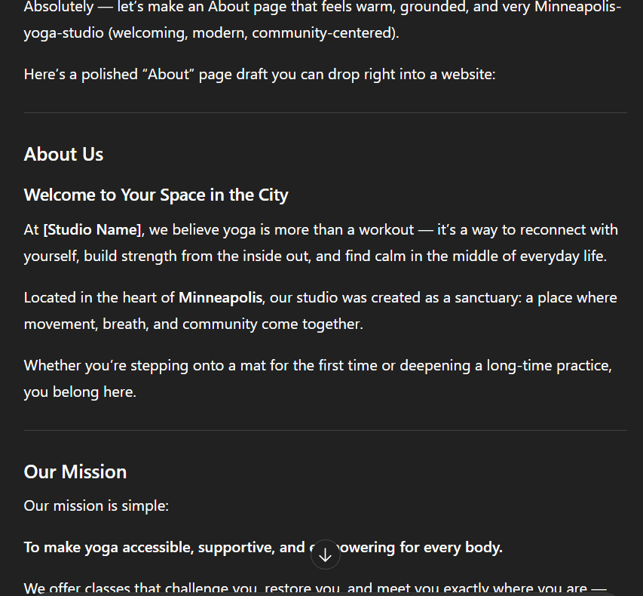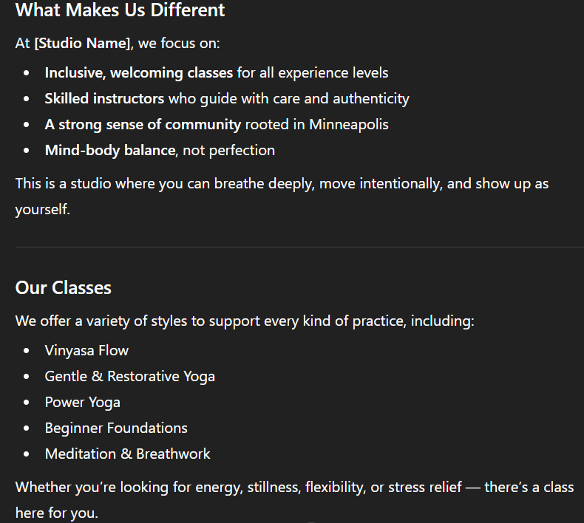
Copilot Screenshot

Gemini Screenshot

Claude Screenshot

Fill in this table
AI Tool | How do you rate the output of your AI tool?
ChatGPT | I like the “output” that the ai created. I would give it a 7/10 in terms of it being general and gets the ball rolling. It give multiple different things that you would usually see on a webpage for a yoga studio. Has a mission statement, an about us page, and a possible book a class button that would presumably take you to a different page where you could sign up.
Copilot
Gemini
Claude

Part 3 Generating code for a real-world scenario – donated blood tracker
Each person, use your AI tool to finish the JavaScript for this problem. It is possible to write a working solution to this problem. The API is public and is up and running correctly. We will study JavaScript and APIs in a future class. It is not necessary to understand JavaScript to complete this part of the assignment.

Scenario: You work for a hospital, and you are working on implementing a new system that provides up-to-date information about donated blood reserves. You have been given this page, https://gist.github.com/claraj/0c745bf7f335eed97b51471575d55420 and need to finish the JavaScript to make the page display the number of blood units for the blood group entered. The page will connect to an API that is tracking the current levels of different blood that the hospital has available. The page should allow the user to select the ABO and Rh blood groups, and then it should show the number of units of that blood group available. The API endpoint is https://blood-group-api.wl.r.appspot.com/.

Ask your AI tool to complete the page.

Insert screenshots of each AI tool’s response.

ChatGPT Screenshot
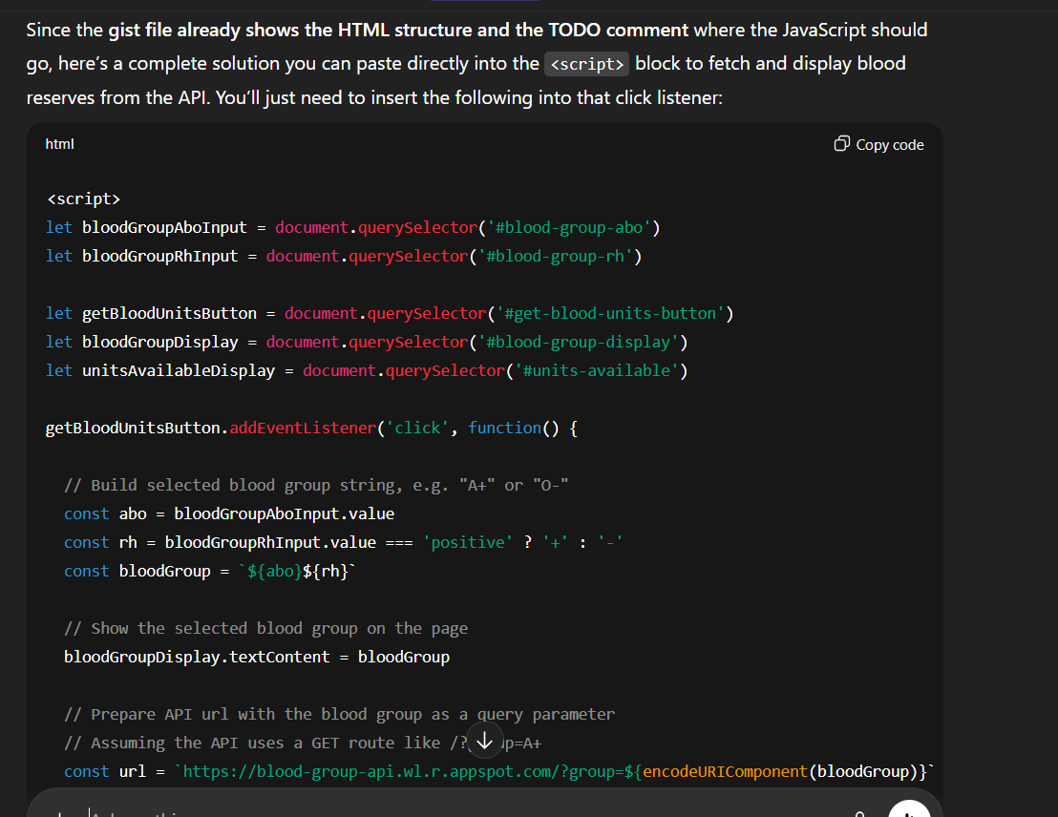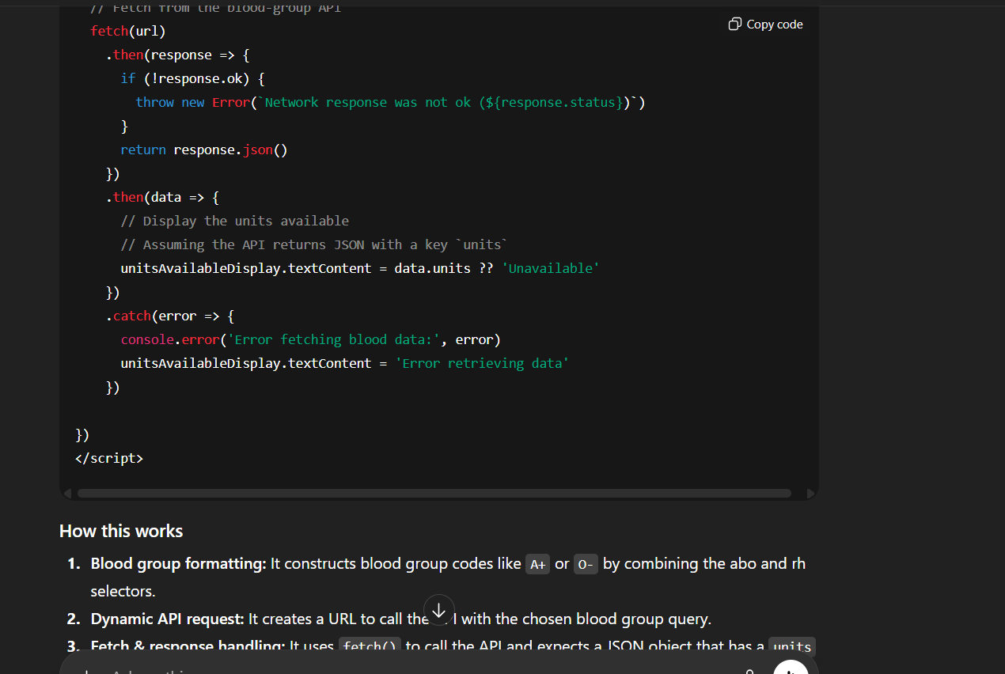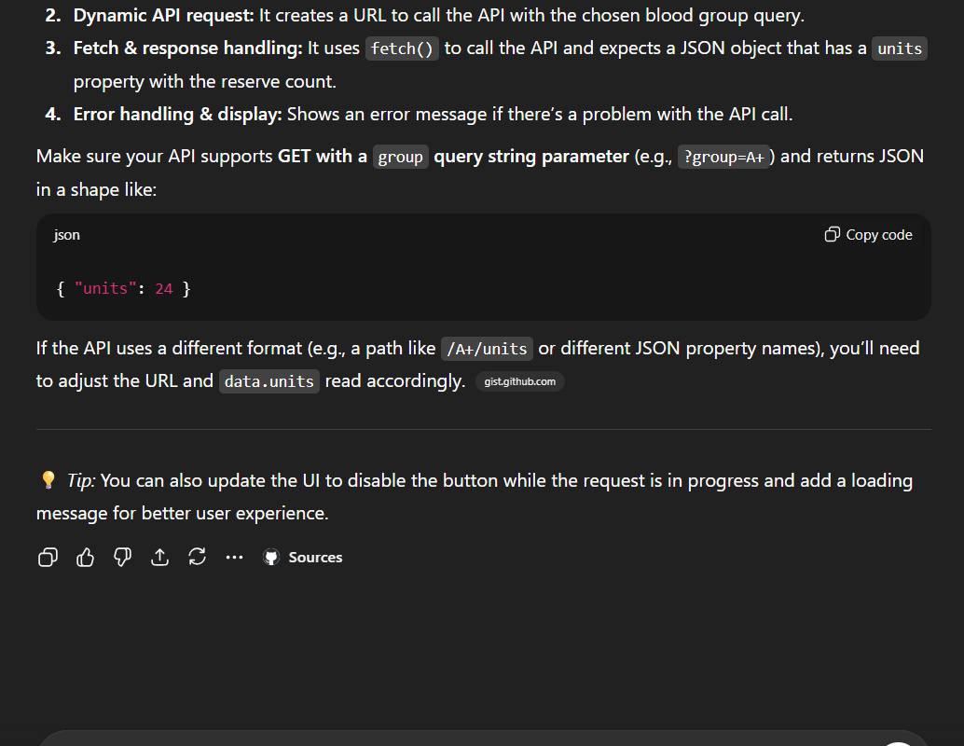

Copilot Screenshot

Gemini Screenshot

Claude Screenshot

- Does the page work? Check the Console of your browser developer tools for errors.
- If you see errors, can the AI tool help you fix them? Tell the AI about the errors and try the suggested solutions.
- Were you able to get the page working?
- Does the code have extra features that were not asked for, for example, loading icons, input validation? Should the AI make assumptions about adding extra things that were not asked for?
- Did it change the user interface? Did it add any styles?
- What other assumptions did it make?
- Are you able to ask the AI to remove extra or unneeded features?
- Can you ask the AI to fix any issues with the page? How many times did you need to ask it to make changes?
- Why do you think the AI tool was successful, or not successful?
- Did the AI tool ask you any questions about the code you asked it to write?
- What assumptions did it make about the problem?
- How confident did the AI tool sound about its solution – is that level of confidence appropriate?

Insert screenshots of your AI-generated page, or if it doesn’t run correctly, screenshots of any error(s) you see.

ChatGPT Code Screenshot
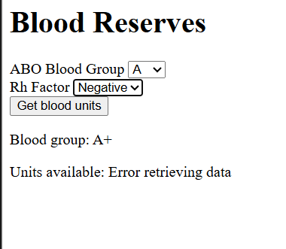
Copilot Code Screenshot

Gemini Code Screenshot

Claude Code Screenshot

Fill in this table
AI Tool | Your assessment of the AI tool output. How successful was it?
ChatGPT | I think that the ai fills out the request and much of the code needed to do what the scenario was good but a lot of the AI is missing general charm and things that would not deem it just functional.
Copilot
Gemini
Claude

Download your shared document. Everyone must upload a copy to D2L and participate in the class discussion, to receive credit for this lab.

